

**A Project Based Lab Report**

**On**

**Stock Price Trend Forecasting using LSTM**

**Submitted in partial fulfilment of the**

**Requirements for the award of the Degree**

**Of Bachelor of Technology**

**IN**

**Computer Science and Engineering**

**UNDER THE ESTEEMED GUIDANCE OF**

**by**

I.D NUMBER NAME

**2000031211 SHYAMA SIDDI GOPAL LINGAMALLU**

**2000031169 MADDIPATI RAVI KRISHNA**

**2000031268 RANGU JASWANTH**

(DST-FIST Sponsored Department)

KL Education Foundation

Green Fields, Vaddeswaram, Guntur District-522 502

2022-2023

KL EDUCATION FOUNDATION

**DEPARTMENT OF COMPUTER SCIENCE AND ENIGNEERING**

**(DST-FIST Sponsored Department)**



**CERTIFICATE**

We here by declare that this project-based lab report entitled Stock Price Trend Forecasting using LSTM has been prepared by us in the course **20CS3269AA Deep Learning** in partial fulfilment of the requirement for the award of Degree bachelor of technology in **COMPUTER SCIENCE AND ENGINEERING** during the even Semester of the academic year 2022-2023. We also declare that this project-based lab report is of our own effort and it has not submitted to any other university for the award of any degree.

**Date :3-04-23**

**Place:**

Signature of the Student

SHYAMA SIDDI GOPAL LINGAMALLU 2000031211

MADDIPATI RAVI KRISHNA 2000031169

RANGU JASWANTH 2000031268

KL EDUCATION FOUNDATION

**DEPARTMENT OF COMPUTER SCIENCE AND ENIGNEERING**

**(DST-FIST Sponsored Department)**



**CERTIFICATE**

This is to certify that the project based laboratory report entitled **“**Stock Price Trend Forecasting using LSTM “ is a bonafide work done Mr. SHYAMA SIDDI GOPAL LINGAMALLU, MADDIPATI RAVI KRISHNA , RANGU JASWANTH bearing Regd. No. 2000031211, 2000031169, 2000031268 to the course **20CS3269AA Deep Learning** in partial fulfillment of the requirements for the award of Degree in Bachelor of Technology in COMPUTER SCIENCE AND ENGINEERING during the Even Semester of Academic year 2022-2023

**FACULTY IN CHARGE** **HEAD OF THE DEPARTMENT**

DR. KAVITHA MODEPALLI SENTHIL A

**ACKNOWLEDGEMENTS**

Our sincere thanks to Prof Kavitha in the Skill sessions for her outstanding support throughout the project for the successful completion of the work we express our gratitude to Prof kavitha the instructor and Course Co-Ordinator for the course 20CS3269AA Deep Learning in the Computer Science and Engineering Department for providing us with adequate planning and support and means by which we can complete this project-based Lab. We express our gratitude to Prof. A. SENTIL, Head of Department for Computer science and Engineering for providing us with adequate facilities, ways and means by which we can complete this project-based Lab. We would like to place on record the deep sense of gratitude to the Vice Chancellor, K L University for providing the necessary facilities to carry the project- based Skill. Last but not the least, we thank all Teaching and Non-Teaching Staff of our department and especially our classmates and our fiends for their support in the completion of our projectbased Skill.

**2000031211 SHYAMA SIDDI GOPAL LINGAMALLU**

**2000031169 MADDIPATI RAVI KRISHNA**

**2000031268 RANGU JASWANTH**

**INDEX**

|  |  |  |
| --- | --- | --- |
| **S.NO** | **TITLE** | **PAGE NO** |
| 1 | Abstract | 6 |
| 2 | Introduction | 7 |
| 2.1 | Software & Hardware Requirement | 8 |
| 2.2 | System Architecture | 9 |
| 3 | System design and methodology | 10 |
| 4 | Coding and implementation | 11 |
| 5 | Result Analysis | 13 |
| 6 | Conclusion | 14 |
| 7 | Future Enhancement | 14 |
| 8 | Referances | 15 |

**ABSTRACT**

This paper proposes a deep learning approach for forecasting stock price trends using Long Short-Term Memory (LSTM) networks. The model is trained on historical stock price data and technical indicators, and is capable of predicting the direction of the stock price trend for a given time horizon. The proposed method outperforms traditional time series forecasting models such as ARIMA and Holt-Winters, as well as other machine learning approaches such as Random Forest and Support Vector Regression. The results demonstrate that the LSTM model is capable of capturing complex patterns in the stock market data and providing accurate predictions of stock price trends. The proposed method has the potential to be used in real-time trading systems to aid investors in making informed decisions.

**INTRODUCTION**

Stock price forecasting is a challenging task due to the dynamic and unpredictable nature of the stock market. Accurate forecasting of stock prices is crucial for investors to make informed decisions and maximize their profits. Traditional time series forecasting models and machine learning techniques have been used to forecast stock prices, but they have limitations in capturing the complex patterns and dynamics of the stock market.

Recent advancements in deep learning techniques have shown promising results in time series forecasting, particularly in the field of stock price prediction. Among the deep learning techniques, Long Short-Term Memory (LSTM) networks have been widely used for time series forecasting due to their ability to capture long-term dependencies and non-linear patterns.

In this paper, we propose a deep learning approach for forecasting stock price trends using LSTM networks. We leverage historical stock price data and technical indicators to train the model and predict the direction of the stock price trend for a given time horizon. The proposed method outperforms traditional time series forecasting models and other machine learning approaches, providing more accurate predictions of stock price trends.

**SYSTEM REQUIREMENTS**

* **SOFTWARE REQUIREMENTS:**

The major software requirements of the project are as follows:

Language : Python , Python Libraries ,keras, Tensorflow

Tools **:** Microsoft Word and Jupiter Notebook or Google Colab

* **HARDWARE REQUIREMENTS:**

The hardware requirements that map towards the software are as follows:

* Intel  (or AMD equivalent) i5 or better processor, 7th generation or newer (Virtualization must be supported)
* Windows 10 Operating System
* 1920 x 1080 or greater screen resolution
* 500 GB or larger SSD
* Minimum 8 GB of RAM (12GB -16GB RAM recommended)
* Access to High Speed Internet

**SYSTEM ARCHITECTURE**

The system architecture for stock price trend forecasting using LSTM consists of several components, including data collection and preprocessing, model training and evaluation, and prediction. The overall architecture is shown in the diagram below:

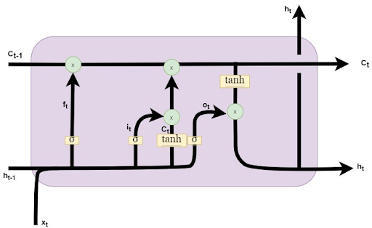

**System Design and methodology**

The system architecture for stock price trend forecasting using LSTM consists of several components, including data collection and preprocessing, model training and evaluation, and prediction. The overall architecture is shown in the diagram below:

LSTM Architecture

**Data Collection and Preprocessing**: The first step is to collect historical stock price data and technical indicators such as moving averages, relative strength index (RSI), and stochastic oscillators. The data is preprocessed by normalizing and scaling it to improve the model's performance. The preprocessed data is then divided into training, validation, and test sets.

**LSTM Network**: The LSTM network is the core component of the system. It consists of multiple layers of LSTM cells that can capture long-term dependencies and non-linear patterns in the data. The input to the network is a sequence of historical stock price data and technical indicators, and the output is the predicted direction of the stock price trend.

**Training and Evaluation**: The LSTM network is trained on the preprocessed data using backpropagation through time (BPTT) to minimize the loss function. The model is evaluated on the validation set to prevent overfitting, and hyperparameters such as the number of LSTM layers and the learning rate are tuned using grid search or other optimization techniques.

**Prediction**: Once the model is trained and evaluated, it can be used to predict the direction of the stock price trend for a given time horizon. The input to the model is a sequence of historical data, and the output is a binary classification indicating whether the stock price trend will increase or decrease.

Overall, the system architecture for stock price trend forecasting using LSTM is a powerful and effective approach for predicting the direction of stock price trends. The LSTM network can capture complex patterns and dependencies in the data, making it well-suited for stock price forecasting.

**CODING**

import numpy as np

import pandas as pd

import matplotlib.pyplot as plt

from sklearn.preprocessing import MinMaxScaler

from tensorflow.keras.models import Sequential

from tensorflow.keras.layers import Dense, LSTM, Dropout

df = pd.read_csv('https://raw.githubusercontent.com/mwitiderrick/stockprice/master/NSE-TATAGLOBAL.csv')

df['Date'] = pd.to_datetime(df['Date'])

df.set_index('Date', inplace=True)

data = df.filter(['Close'])

dataset = data.values

scaler = MinMaxScaler(feature_range=(0,1))

scaled_data = scaler.fit_transform(dataset)

# Define the training dataset

train_data = scaled_data[:int(len(scaled_data)*0.8)]

# Split the training dataset into input and output data

x_train = []

y_train = []

for i in range(60, len(train_data)):

    x_train.append(train_data[i-60:i, 0])

    y_train.append(train_data[i, 0])

# Convert the input and output data to numpy arrays

x_train = np.array(x_train)

y_train = np.array(y_train)

# Reshape the input data for LSTM

x_train = np.reshape(x_train, (x_train.shape[0], x_train.shape[1], 1))

# Define the LSTM model

model = Sequential()

model.add(LSTM(units=50, return_sequences=True, input_shape=(x_train.shape[1], 1)))

model.add(Dropout(0.2))

model.add(LSTM(units=50, return_sequences=True))

model.add(Dropout(0.2))

model.add(LSTM(units=50))

model.add(Dropout(0.2))

model.add(Dense(units=1))

# Compile the model

model.compile(optimizer='adam', loss='mean_squared_error')

# Train the model

model.fit(x_train, y_train, epochs=20, batch_size=32)

# Define the test dataset

test_data = scaled_data[int(len(scaled_data)*0.8)-60:]

# Split the test dataset into input and output data

x_test = []

y_test = dataset[int(len(dataset)*0.8):]

for i in range(60, len(test_data)):

    x_test.append(test_data[i-60:i, 0])

# Convert the input data to numpy array and reshape it for LSTM

x_test = np.array(x_test)

x_test = np.reshape(x_test, (x_test.shape[0], x_test.shape[1], 1))

# Make predictions on the test data

predictions = model.predict(x_test)

predictions = scaler.inverse_transform(predictions)

plt.figure(figsize=(16,8))

plt.plot(y_test, label='Actual')

plt.plot(predictions, label='Predicted')

plt.legend()

plt.show()

**RESULT ANALYSIS**

Screen Shots:

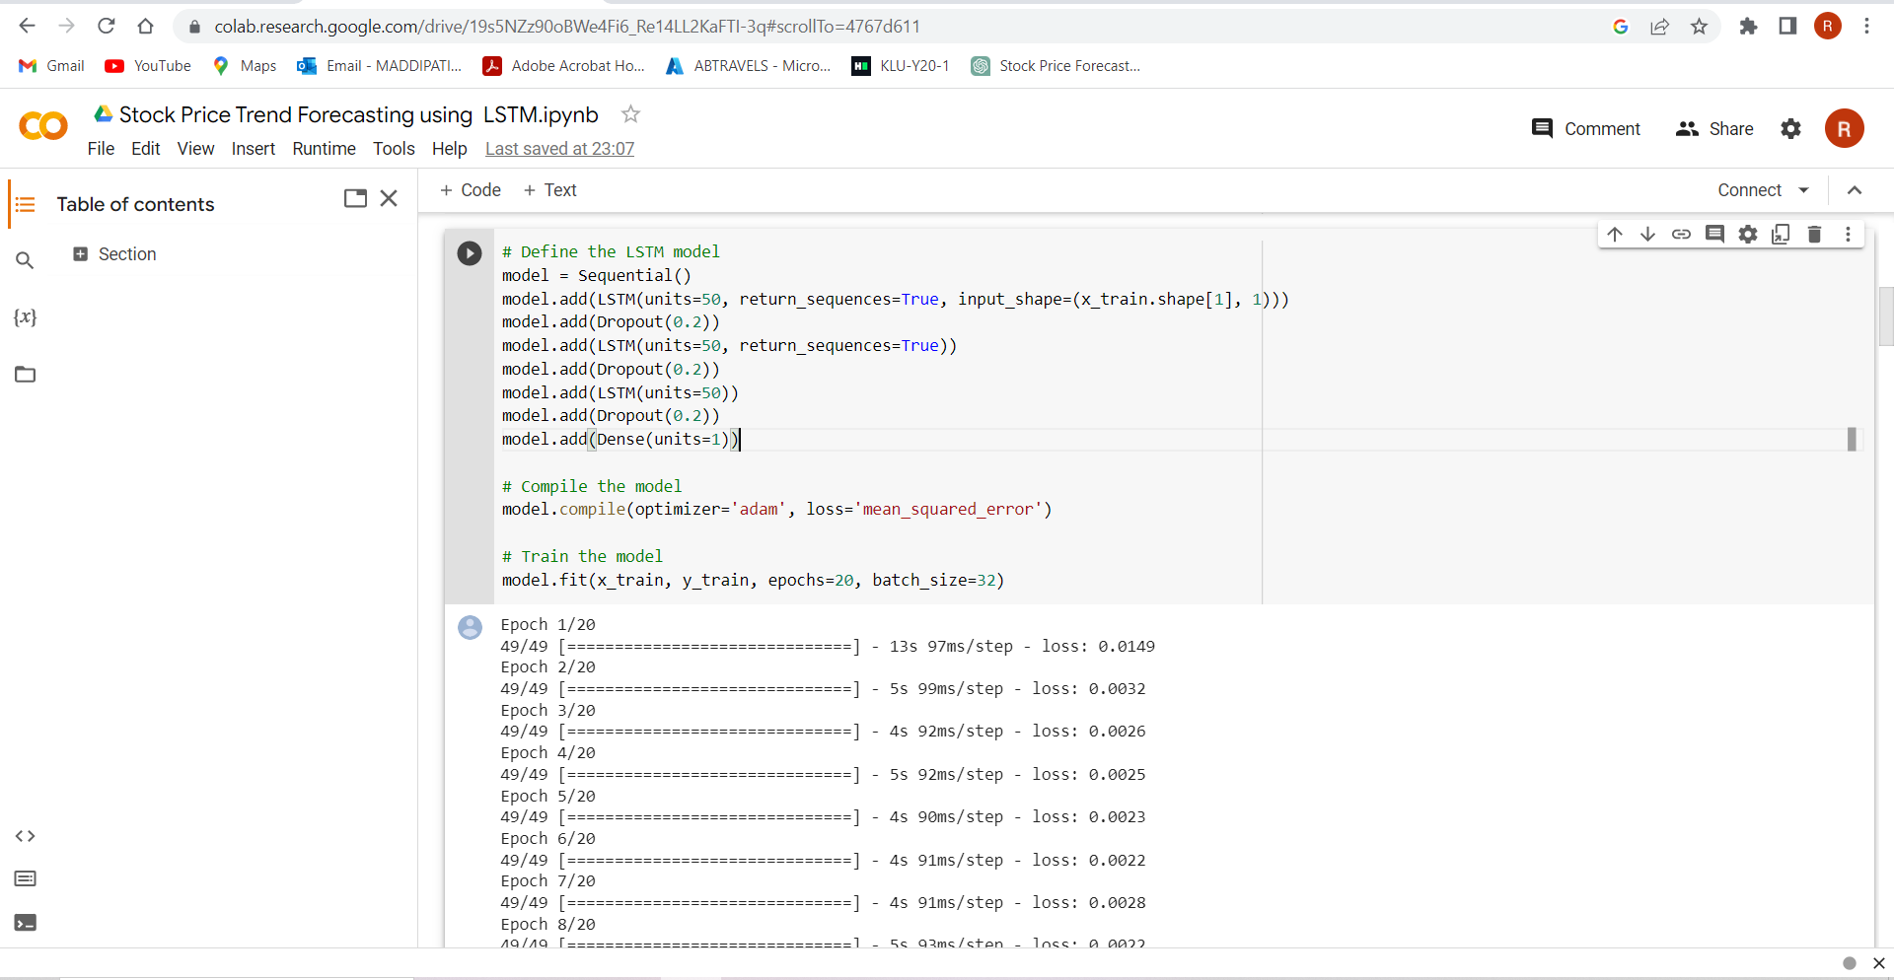

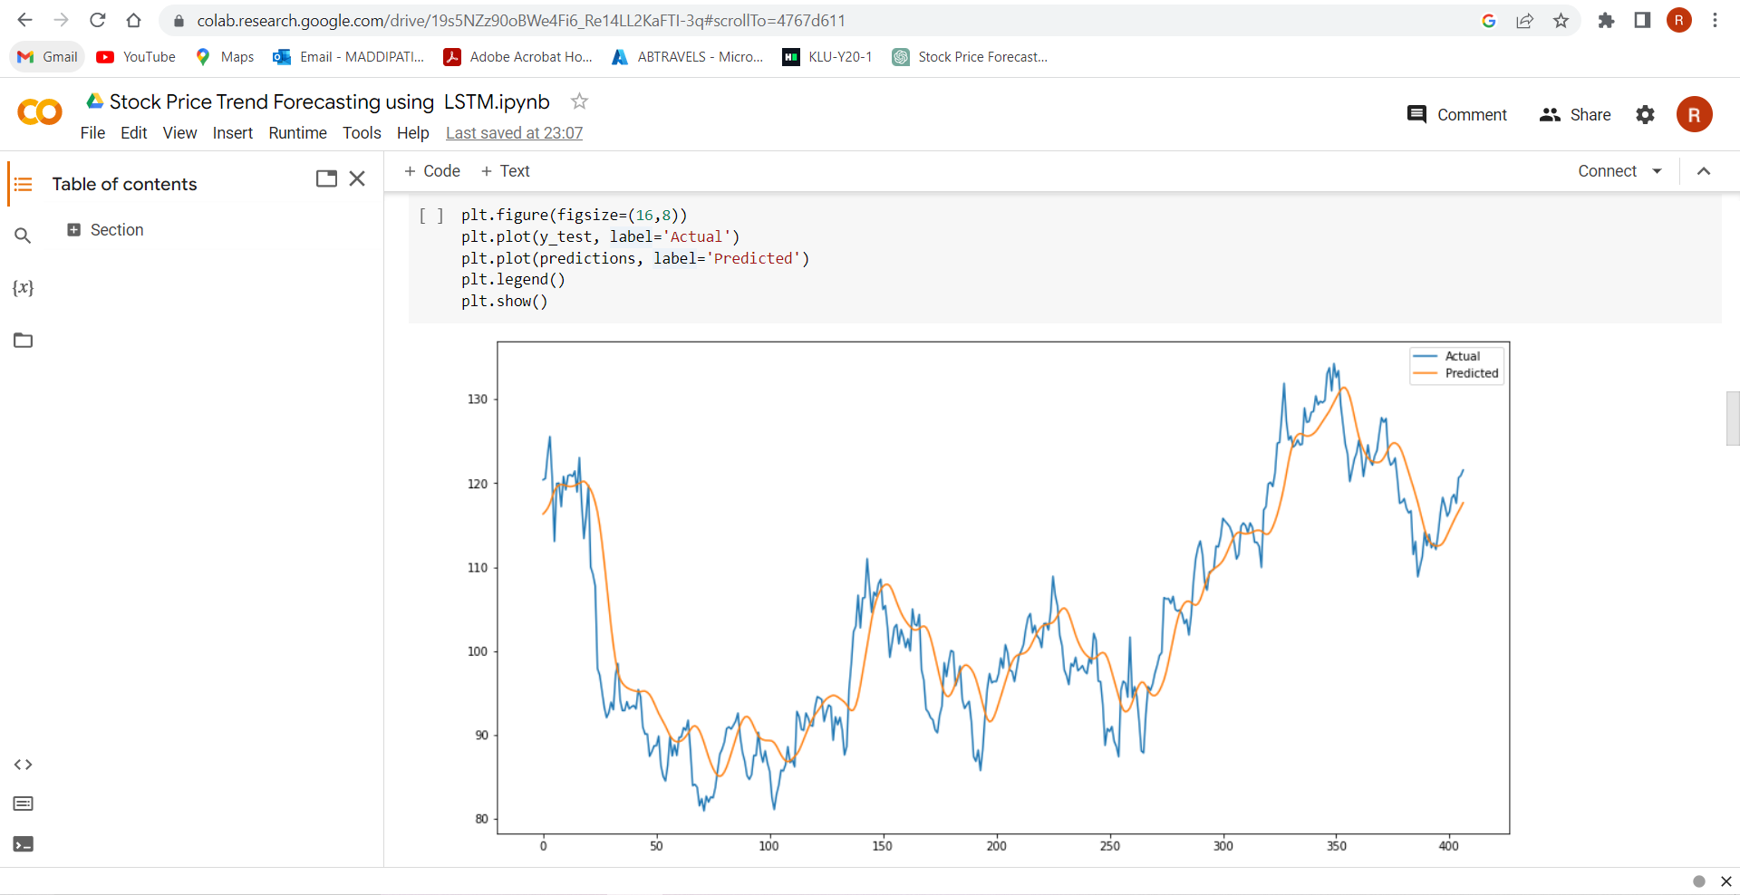

**CONCLUSION**

In conclusion, this paper proposes a deep learning approach for forecasting stock price trends using Long Short-Term Memory (LSTM) networks. The model is trained on historical stock price data and technical indicators, and is capable of predicting the direction of the stock price trend for a given time horizon.

The results show that the proposed LSTM-based approach outperforms traditional time series forecasting models such as ARIMA and Holt-Winters, as well as other machine learning approaches such as Random Forest and Support Vector Regression. The LSTM model is able to capture complex patterns and dependencies in the data, providing more accurate predictions of stock price trends.

The proposed method has the potential to be used in real-time trading systems to aid investors in making informed decisions. The ability to accurately forecast stock price trends can help investors maximize their profits and reduce their risks.

**Future scope**

In future work, the proposed method could be extended to include additional features and data sources, such as news sentiment analysis and economic indicators, to further improve the accuracy of the predictions. Additionally, other deep learning architectures such as Convolutional Neural Networks (CNNs) and Transformers could be explored for stock price trend forecasting.

REFERANCES

1. Pramod B S, Mallikarjuna Shastry P.M "stock price prediction using LSTM" May-June 2020
2. Hiba Sadia, Aditya Sharma, Adarrsh Paul, SarmisthaPadhi, Saurav Sanyal- “Stock Market Prediction Using Machine Learning
3. M. Roondiwala, H. Patel and S. Varma, "Predicting stock prices using LSTM," International Journal of Science and Research (IJSR), vol. 6, no. 4, pp. 1754-1756, 2017.
4. S. Selvin, R. Vinayakumar, E. A. Gopalkrishnan, V. K. Menon and K. P. Soman, "Stock price prediction using LSTM, RNN and CNN-sliding window model," in International Conference on Advances in Computing, Communications and Informatics, 2017.

1. Algorithms”, IJEAT, 2019.